Continuity of Operations Plan
(COOP)
June 1, 2007
Revision A

SP-4 Continuity of Operations Plan (COOP) 3
Introduction 3
Description 3
Purpose 3
Principles 3
Content 3
1. COOP Activation 4
2. COOP Roles and Responsibilities 4
3. COOP Checklist 4
Planning 4
Execution 4
4. COOP Relocation Site Map and Directions 5
5. COOP Relocation Site Activation 5
West Coast Site 6
Mid-America Site 6
East Coast Site 6
6. COOP Relocation Site Inventory 7
Los Angeles to West Coast Site 7
Houston to Mid-America Site 7
Jacksonville to East Coast Site 7
Phoenix to West Coast Site 7
Denver to Mid-America Site 7
7. COOP Relocation Site De-Activation 8
Los Angeles - West Coast Site 8
Houston - Mid-America Site 8
Jacksonville - East Coast Site 8
Phoenix – West Coast Site 8
Denver – Mid-America Site 8

SP-4 Continuity of Operations Plan (COOP)

Introduction

Description
The Continuity of Operations Plan (COOP) uses a standard format for describing where all or part of the enterprise will relocate to if the normal operating location cannot be occupied for an extended period of time (more than a few days) due to the natural or man-made event.

Purpose
The activation of the COOP relocation site may have to be accomplished in the midst of a local or national disaster that makes clarity, brevity, completeness, and flexibility (backups) key to success.

Principles
Enterprise functions have to relocate.

Content
The COOP document contains the following elements: Activation; Roles and Responsibilities; Checklist; Relocation Map and Directions; Relocation Site Activation; Relocation Site Inventory; and Relocation Site De-activation.

TOPIC | DESCRIPTION
Activation | This section describes the conditions for activating the COOP
Roles and Responsibilities | This section contains a matrix of the roles and responsibilities (by position) of all personnel throughout the enterprise who are involved in activating the COOP. Alternates are provided for each position.
Checklist | This section contains is a step-by-step checklist of actions for each person participating in the COOP.
Relocation Map and Directions | This section describes how to get to the COOP site from various probable routes.
Relocation Site Activation | This is the process for activating the COOP site, establishing internal/external communications, and reconstituting key enterprise functions at the COOP site.
Relocation Site Inventory | This is an inventory of systems, equipment, and supplies at the COOP relocation site, along with the person(s) responsible for ensuring that the systems are operational and the equipment is present when needed.
Relocation Site De-activation | These are the procedures for de-activating the COOP site and restoring it to a ‘ready status’ after a real relocation event or training exercise.

COOP Activation
This plan will be activated at the request of any of the following job positions: President, CEO, COO, CIO, VP IT Operations, DMC Security Manager, or Division Security Manager. Activating a Relocation Site requires the approval of the CEO, President, or COO.

COOP Roles and Responsibilities
Role | Responsibility | Primary | Alternate
Authorizer | Provides requirements to IT for Continuity of Operations | COO, CFO, & Chief Counsel | Division VP; Administration VP, IT Operations VP; Deputy Chief Counsel
Planner | Develops the COOP. | SolMed Security Manager | Division Security Managers
Initiator | Activates the COOP | President, CEO, COO, CIO, VP IT Operations, SolMed Security Manager, or Division Security Manager. | N/A
Executor | Activates and de-activates sites | Division VP | Deputy Division VP

COOP Checklist

Planning
ITEM | ACTION | ROLE
1 | Assess company. | SolMed Security Manager
2 | Identify needs of customers and suppliers. | COO & CIO
3 | Plan for a sub-site emergency. | Division VP & Division Security Manager
4 | Plan for site emergency. | Division VP & Division Security Manager
5 | Plan for corporate headquarters emergency. | CEO & CIO
6 | Exercise plan annually. | ALL

Execution
ITEM | ACTION | ROLE
1 | Activate plan. | President, CEO, COO, CIO, VP IT Operations, SolMed Security Manager, or Division Security Manager
2 | Decide on site or sub-site deactivation. | CEO, COO, CIO
3 | Activate COOP site or sub-site. | Division VP or COO
4 | De-activate site or sub-site. | Division VP or COO
5 | Monitor situation. | SolMed Security Manager
6 | Activate original site of sub-site. | Division VP or COO
7 | De-activate COOP site or sub-site. | Division VP or COO

COOP Relocation Site Map and Directions
  - Denver, CO –Mid-America is the alternate for Denver, CO, with computing temporarily relocated to the SolMed Jacksonville site.
  - Houston, TX – Mid-America is the alternate for Houston, TX, with computing temporarily relocated to the SolMed Jacksonville site.
  - Jacksonville, FL – East Coast Site is the alternate for Jacksonville, FL, with computing temporarily relocated to the SolMed Houston site.
  - Los Angeles, CA – West Coast is the alternate for Los Angeles, CA, with computing temporarily relocated to the SolMed Jacksonville site
  - Phoenix, AZ– West Coast is the alternate for Phoenix, AZ, with computing temporarily outsourced to a third party site that is a minimum of 500 miles from Phoenix.

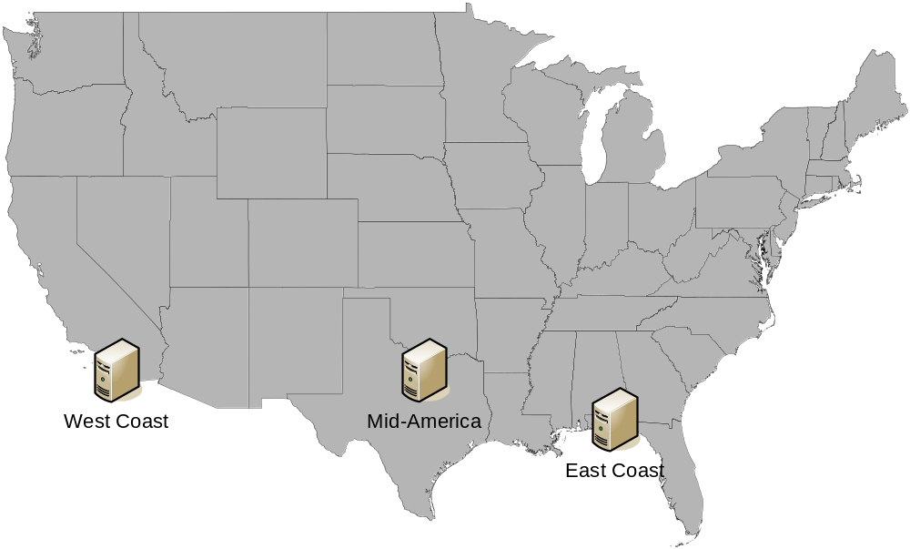

COOP Relocation Site Activation

West Coast Site
- The Los Angeles site will relocate to San Diego, CA after proper authorization. Empty office space will be arranged through ReMax Commercial in San Diego.
- IT and Facilities will reconstitute the Sales department office.
- Enterprise computing will be relocated temporarily to Jacksonville, FL
- The Phoenix site will relocate to San Diego, CA in the event of a catastrophic event. Sales Office facility will be arranged through ReMax Commercial in San Diego.
- IT and Facilities will reconstitute the Sales department office.
- Enterprise computing will be temporarily outsourced to a third party site located a minimum of 500 miles from Phoenix.

Mid-America Site
- The Houston site will relocate to Dallas, TX in the event of a catastrophic event. Office space and factory facilities will be arranged through ReMax Commercial in Dallas, TX.
- IT and Facilities will reconstitute the Corporate Offices, Manufacturing Plant, Warehouse/Distribution Center, Sales Offices and Product Development Center.
- Enterprise computing will be relocated temporarily to Jacksonville, FL.
- The Denver site will relocate to Dallas, TX in the event of a catastrophic event. Manufacturing Plant, Sales Office and Product Development Center facilities will be arranged through ReMax Commercial in Dallas, TX.
- IT and Facilities will reconstitute the Manufacturing Plant, Sales Office and Product Development Center facilities.
- Enterprise computing will be relocated temporarily to Jacksonville, FL.

East Coast Site
- The Jacksonville site will relocate to Pensacola, FL in the event of a catastrophic event. Manufacturing Plant, Warehouse/Distribution Center, Sales Office and Product Development Center facilities will be arranged through ReMax Commercial in Pensacola, FL.
- IT and Facilities will reconstitute the office and factory space.
- Enterprise computing will be relocated temporarily to Houston, TX.

COOP Relocation Site Inventory

Los Angeles to West Coast Site
- Inventory:
  - No inventory will be kept in San Diego. All computing will be re-constituted from Dell through our corporate purchasing agreement.
- Point of contact
  - Sales Office: Judy Jettson

Houston to Mid-America Site
- Inventory: Systems, equipment, and supplies list are available from the SolMed Security Manager.
- Points of contact
  - Corporate Headquarters: Robert Fuller
  - Consumer Products Division: George Goshwin
  - Medical Products Division: Edie Lawrence
  - Sales Office: Kelly Kirkpatrick

Jacksonville to East Coast Site
- Inventory: Systems, equipment, and supplies list are available from the SolMed Security Manager.
- Points of contact
  - Consumer Products Division: Andy Miller
  - Industrial Products Division: Bob Bellows
  - Medical Products Division: Candy Kane
  - Sales Office: Danny Devito

Phoenix to West Coast Site
- Inventory:
  - No inventory will be kept in San Diego. All computing will be re-constituted from Dell through our corporate purchasing agreement.
- Point of contact
  - Sales Office: Robert Hope

Denver to Mid-America Site
- Inventory: Systems, equipment, and supplies list are available from the SolMed Security Manager.
- Points of contact
  - Industrial Products Division: Jonathan Doe
  - Sales Office: David Baumgartner

COOP Relocation Site De-Activation

Los Angeles - West Coast Site
- The Los Angeles office will be evaluated and refurbished as needed. The Sales Department will determine a ‘ready’ status.
- The San Diego office will relocate back to Los Angeles.
- The San Diego Office will be de-activated two weeks after the Los Angeles office is re-activated.

Houston - Mid-America Site
- The Houston facilities will be evaluated and refurbished as needed. Each division will determine a ‘ready’ status.
- The Dallas offices and factory equipment will relocate back to Houston.
- The Dallas site will be de-activated four weeks after the Houston office is re-activated.

Jacksonville - East Coast Site
- The Jacksonville facilities will be evaluated and refurbished as needed. Each division will determine a ‘ready’ status.
- The Pensacola offices and factory equipment will relocate back to Jacksonville.
- The Pensacola site will be de-activated four weeks after the Jacksonville office is re-activated.

Phoenix – West Coast Site
- The Phoenix office will be evaluated and refurbished as needed. The Sales Department will determine a ‘ready’ status.
- The San Diego office will relocate back to Phoenix.
- The San Diego Office will be de-activated two weeks after the Phoenix office is re-activated.

Denver – Mid-America Site
- The Denver facilities will be evaluated and refurbished as needed. Each division will determine a ‘ready’ status.
- The Dallas offices and factory equipment will relocate back to Denver.
- The Dallas site will be de-activated four weeks after the Denver office is re-activated.

